Child Development with the D-score: Turning Milestones into Measurement

Authors: Stef van Buuren & Iris Eekhout

# Preface

The foundations of adult health and wellbeing have their origins early in life, often measured by children’s early growth and development (Clark et al. 2020). Growth standards established by the World Health Organization (WHO) have been adopted globally, and are used as indices and targets for improvement. For example, in 2018, 219 million children under 5 years of age (21.9%) were stunted (height for age < -2 standard deviations of the WHO growth standards) (UNICEF 2019). Stunting early in life has been associated with negative childhood development, academic achievement, and adult productivity. In the absence of direct population-based metrics for childhood development, stunting and poverty have been used as proxy indicators to estimate the number of children not reaching their developmental potential (Lu, Black, and Richter 2016).

Although stunting and poverty have been effective indicators and have contributed to advances in global childhood development policies and programs (Black et al. 2017), they lack the sensitivity to measure changes associated with programmatic interventions. Early childhood development is a latent construct comprised of an ordinal sequence of developmental domains (motor, language, cognitive, personal-social). A valid and easily interpretable metric is needed to interpret the underlying latent construct of early childhood development that can represent change and is comparable across cultures and contexts. Chapter I - [Turning milestones into measurement](https://d-score.org/dbook1) - shows that the D-score (Developmental score) meets those criteria.

Chapter II - [Tuning instruments to unity](https://d-score.org/dbook2) - deals with the problem of how to define and calculate the D-score from data obtained from multiple studies and multiple instruments. After harmonizing longitudinal measures of childhood development among over 36,000 children from 11 countries (Weber et al. 2019), the statistical analysis produced a D-score scale with interval qualities that can reflect change over time and enable within and across country comparisons. In addition, the D-score is responsive to environmental conditions that may impact children’s development, ranging from community programs and policies to macro-level conditions from migration, inequities, or climate. Applied to populations, direct metrics of children’s early growth and development assess the current status of the population’s health and well-being, establish predictions of future health and well-being, and provide opportunities to measure changes. Thus, applying the D-score to the early development of children extends to populations and society as a whole.

Maureen Black (July, 2020)

# 1 Introduction

This introductory section outlines why we utilize the D-score:

* reviewing key discussions about the first 1000 days in a child’s life (1.1)
* highlighting the relevance of early childhood development for later life (1.2)
* discussing the use of stunting as a proxy for development (1.3)
* pointing to existing instruments to quantify neurocognitive development (1.4)
* explaining why we have written this chapter (1.5)
* delineating the intended audience (1.6)

## 1.1 First 1000 days

The *first 1000 days* refers to the time needed for a child to grow from conception to the second birthday. It is a time of rapid change. During this period the architecture of the developing brain is very open to the influence of relationships and experiences (Shonkhoff et al. 2016). Early experiences affect the nature and quality of the brain’s developing architecture by reinforcing some synapses and pruning others through lack of use. The first 1000 days shape the brain’s architecture, but higher-order brain functions continue to develop into adolescence and early adulthood (Kolb, Harker, and Gibb 2017).

The classic *nature versus nurture debate* contrasts the viewpoints that variation in development is primarily due to either genetic or environmental differences. The current scientific consensus is that both genetic predisposition and ecological differences influence all traits (Rutter 2007). The environment in which a child develops (before and soon after birth) provides experiences that can modify gene activity (Caspi et al. 2010). Negative influences, such as exposure to stressful life circumstances or environmental toxins may leave a *chemical signature* on the genes, thereby influencing how genes work in that individual.

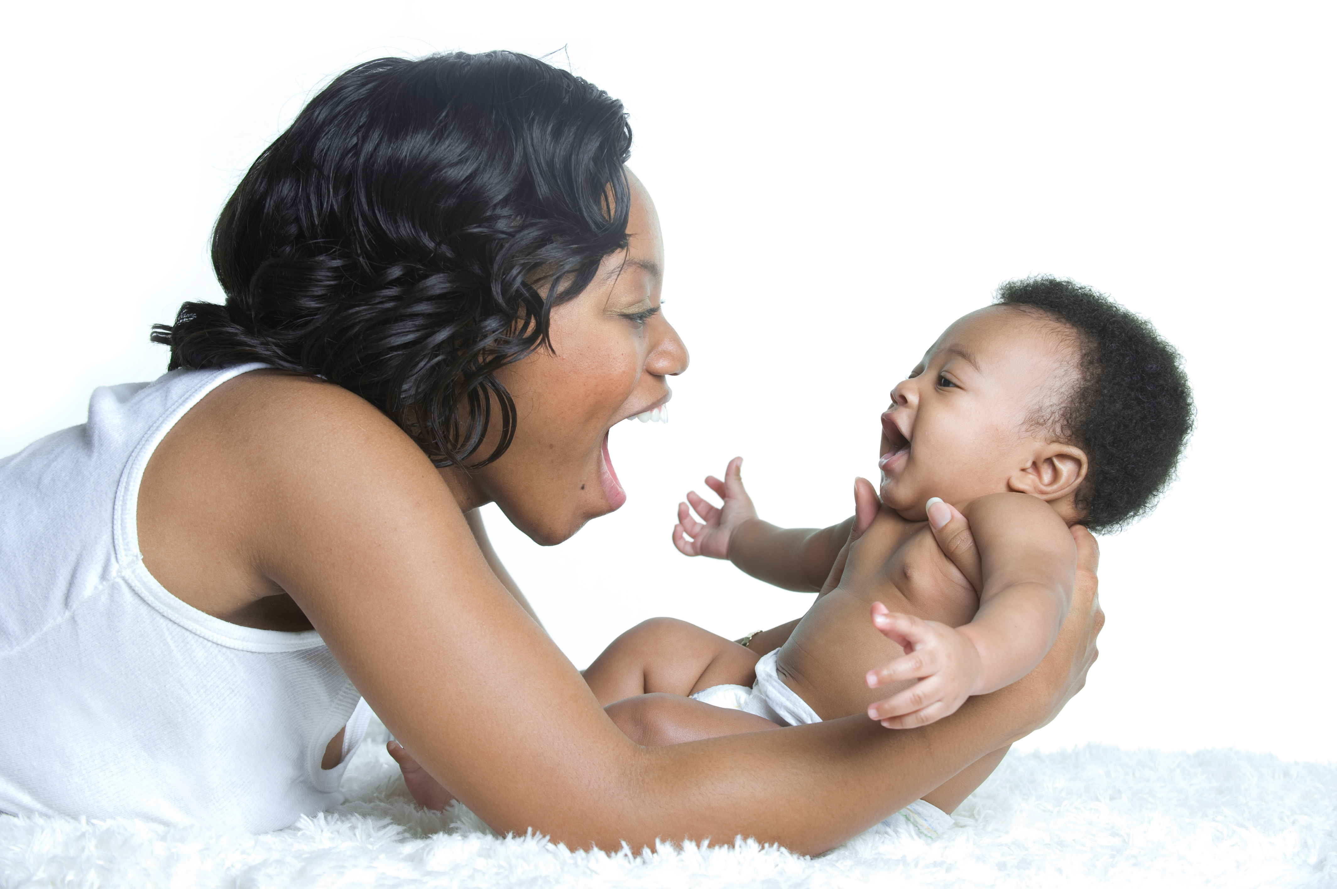

Figure 1.1: Serve and return interactions shape brain architecture. Source: Shutterstock, under license.

During the first 1000 days, infants are highly dependent on their caregivers to protect them from adversities and to help them regulate their physiology and behavior. As Figure 1.1 illustrates, caregivers can do this through responsive care, including routines for sleeping and feeding. To reach their developmental potential, children require nutrition, responsive caregiving, opportunities to explore and learn, and protection from environmental threats (Black et al. 2017). Gradually, children build self-regulatory skills that enable them to manage stress as they interact with the world around them (Johnson et al. 2013).

## 1.2 Relevance of child development

The first 1000 days is a time of rapid change. Early experiences affect brain development and influence lifelong learning and health (Shonkhoff et al. 2016). Healthy development is associated with future school achievement, well-being, and success in life (Bellman, Byrne, and Sege 2013).

Professionals and parents consider it important to monitor children’s development. Tracking child development enables professionals to identify children with signs of potential delay. Timely identification can help children and their parents to benefit from early intervention. In a normal population, developmental delay affects about 1–3% of children. A delay in development may indicate underlying disorders. About 1% of children have an autism spectrum disorder (Baird et al. 2006), 1–2% a mild learning disability, and 5–10% have a specific learning disability in a single domain (Horridge 2011).

Children develop at different rates, and it is vital to distinguish those who are within the “normal” range from those who are following a more pathological course (Bellman, Byrne, and Sege 2013). There is good evidence that early identification and early intervention improve the outcomes of children (Britto et al. 2017). Early intervention is crucial for children with developmental disabilities because barriers to healthy development early in life impede progress at each subsequent stage.

Monitoring child development provides caregivers and parents with reliable information about the child and an opportunity to intervene at an early age. Understanding the developmental health of populations of children allows organisations and policymakers to make informed decisions about programmes that support children’s greatest needs (Bellman, Byrne, and Sege 2013).

## 1.3 Stunting as proxy for child development

Stunting is the impaired physical growth and development that children experience from poor nutrition, repeated infection, and inadequate psychosocial stimulation. Linear growth in children is commonly expressed as length-for-age or height-for-age in comparison to normative growth standards (Wit et al. 2017). According to the World Health Organization (WHO), children are stunted if their height-for-age is more than two standard deviations below the Child Growth Standards median. Stunting caused by chronic nutritional deprivation in early childhood is as an indicator of child development (Perkins et al. 2017).

There is consistent evidence for an association between stunting and poor child development, despite heterogeneity in the estimation of its magnitude (Miller et al. 2016; Sudfeld et al. 2015). Considering impaired linear growth as a proxy measure for child development is easy to do, and quite common. Yet, using impaired height growth as a measure for child development is not without limitations:

* The relation between height and child development is weak after adjustment for age;
* Height is a physical indicator that does not take into account a direct evaluation of a child’s cognitive or mental performance;
* There is considerable heterogeneity in heights of children all over the world;
* Height is not sensitive to rapid changes in child development.

## 1.4 Measuring neurocognitive development

Assessment of early neurocognitive development in children is challenging for many reasons (Ellingsen 2016). During the first years of life, developmental change occurs rapidly, and the manifestation of different skills and abilities varies considerably across children. Moreover, a child’s performance on a cognitive task is very susceptible to measurement setting, timing and the health of the child that day.

Recently, a toolkit was published that reviews 147 assessment tools developed for children ages 0–8 years in low- and middle-income countries (Fernald et al. 2017). Some of the most widely used tools include the Ages & Stages Questionnaires (ASQ), Achenbach Child Behavior Checklist (CBCL), Bayley Scales of Infant Development (BSID), Denver Developmental Screening Test (DEN), Griffiths Scales of Child Development (GRF), Mullen Scale of Early Learning (MSEL), Strengths and Difficulties Questionnaire (SDQ), Wechsler Intelligence Scale for Children (WISC), and its younger age counterpart Wechsler Preschool and Primary Scale of Intelligence (WPPSI).

Each of these tools has its strengths and limitations. For example, the ASQ and DEN are screeners for general child development. The CBCL and SDQ are screeners for behavioral and mental health, not cognition or general development. DEN is relatively easy and quick to administer, but not very precise. It is out of production, not being sold or re-normed. The BSID, MSEL, and GRF provide a clinical assessment at the individual level and requires a skilled professional to administer. Some instruments collect observations through the caregiver (ASQ), whereas others emphasize traits and behavior over performance (SDQ, CBCL). Also, the age ranges to which the instruments are sensitive vary. Furthermore, they may cover different domains of development.

The ideal child development assessment would be easy to administer and has high reliability, validity, and cross-cultural appropriateness. It should also show appropriate sensitivity in scores at different ages and ability levels. It is no surprise that no test can meet all of these criteria. Many tests are too long, difficult to administer, lack cross-cultural validity, or have low reliability. Also, many instruments are proprietary and costly to use.

## 1.5 Why this chapter?

We believe that **there cannot be one instrument** for measuring child development that is suitable for all situations. In general, the tool needs tailoring to the setting. For example, to find a delayed child, we need an instrument that is precise for that individual child, and that is sensitive to different domains of delay. In contrast, if we want to estimate the proportion of children that is *developmentally on track* in a region, we need one culturally unbiased, relatively imprecise low-cost measurement made on many children across many ages. The optimal instrument will look quite different in both cases.

We also believe that **there can be one scale** for measuring child development and that this scale is useful for many applications. Such a scale is similar to well-known measures for body height, body weight or body temperature. These measurements have a clearly defined unit (i.e., centimetre, kilogram, degree Celsius), which moreover is assumed to be constant across all scale locations. We express measurements as the number of scale units (e.g. 92 cm). Note that there may be multiple instruments for measuring a child height (e.g. ruler, laser distance meter, echolocation, ability to reach the door handle, and so on). Still, their result translates into scale units (cm here). The opposite is also true, and perhaps more familiar. We may have one instrument and express the result in multiple units (e.g. cm, inches, light-years).

Instruments and scales are different things. Currently, instruments for measuring child development define their own scales, which renders the measurements made by distinct tools incomparable. No measurement unit for child development yet exists. It would undoubtedly be an advance if we could tailor the measurement instrument to the setting while retaining the advantage of a scale with a clearly defined unit across different tools. We can then compare the data collected by distinct devices. This chapter explores the theory and practice for making that happen.

## 1.6 Intended audience

We aim for three broad audiences:

* Professionals in the field of child growth and development;
* Policymakers in international settings;
* Statisticians, methodologists, and data scientists.

Professionals in child development will become familiar with a new approach to measuring child development in early childhood. We plan to separate the measurement instrument from the scale used to express the result. This formulation allows the user **to select the instrument most suited for a particular setting**. Since instruments differ widely in age coverage, length, administration mode, and domain coverage (Boggs et al. 2019), the ability to choose the instrument, while not giving up comparability, represents a significant advance over routines that marry the scale to the instrument.

Policymakers in international settings wish to know the effect of different interventions on child development. Gaining insight into such effects is not so easy since different studies use different instruments. The ability to place measurements made by different instruments onto the same scale will allow for a **more accurate understanding of policy effects**. It also enables the setting of priorities and actions that are less dependent on the way the data were collected.

Statisticians and data scientists generally prefer numeric values with an unambiguous unit (e.g., centimeters, kilograms) over a vector of dichotomous data points. This chapter shows how to convert a series of PASS/FAIL scores to a numeric value with interval scale properties. The existence of such a scale opens the way for the **application of precise analytic techniques**, similar to those applied to child height and body weight. The techniques have a solid psychometric backing, and also apply to other types of problems.

# 2 Short history

The measurement of child development has quite an extensive history. This section

* reviews definitions of child development (2.1)
* discusses concepts in the nature of child development (2.2)
* shows a classic example of motor measurements (2.3)
* summarizes typical questions whose answers need proper measurements (2.4)

## 2.1 What is child development?

In contrast to concepts like height or temperature, it is unclear what exactly constitutes child development. Shirley (1931) executed one of the first rigorous studies in the field with the explicit aim

that the many aspects of development, anatomical, physical, motor, intellectual, and emotional, be studied simultaneously.

Shirley gave empirical definitions of each of these domains of development.

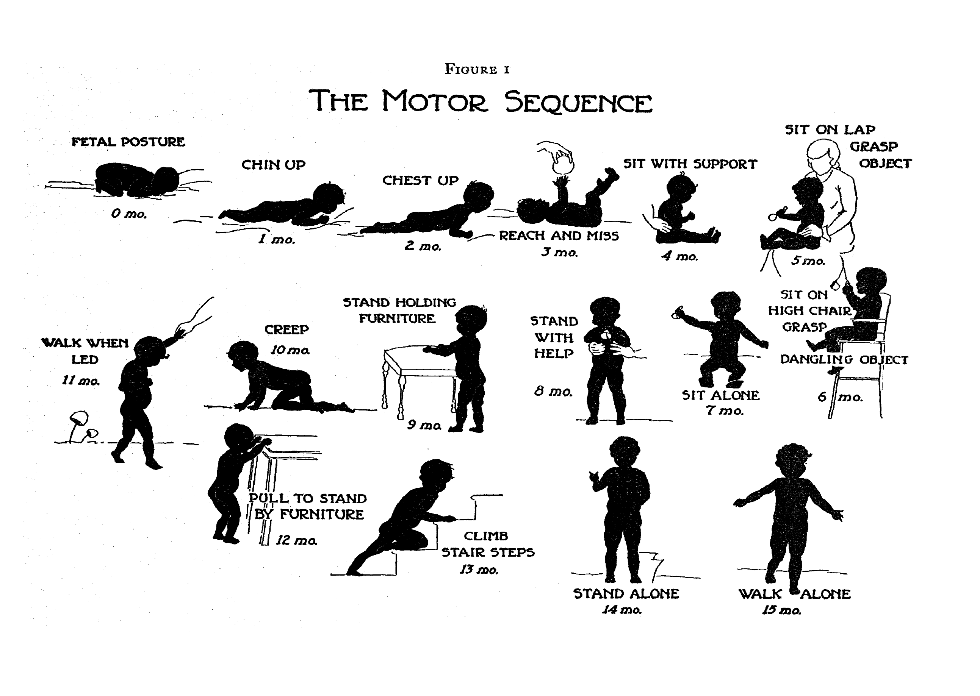

Figure 2.1: Gross motor development as a sequence of milestones. Source: Shirley (1933), with permission.

Certain domains advance through a fixed sequence. Figure 2.1 illustrates the various stages needed for going from a *fetal posture* to *walking alone*. The ages are indicative of when these events happen, but there is a considerable variation in timing between infants.

Gesell (1943) (p. 88) formulated the following definition of development:

Development is a continuous process that proceeds stage by stage in an orderly sequence.

Gesell’s definition emphasizes that development is a continuous process. The stages are useful as indicators to infer the level of maturity but are of limited interest by themselves.

Liebert, Poulos, and Strauss (1974) (p. 5) emphasized that development is not a phenomenon that unfolds in isolation.

Development refers to a process in growth and capability over time, as a function of both maturation and interaction with the environment.

Cameron and Bogin (2012) (p. 11) defined an endpoint of development, as follows:

“Growth” is defined as an increase in size, while “maturity” or “development” is an increase in functional ability…The endpoint of maturity is when a human is functionally able to procreate successfully … not just biological maturity but also behavioural and perhaps social maturity.

Berk (2011) (p. 30) presented a dynamic systems perspective on child development as follows:

Development cannot be characterized as a single line of change, and is more like a web of fibres branching out in many directions, each representing a different skill area that may undergo both continuous and stagewise transformation.

There are many more definitions of child development. The ones described here illustrate the main points of view in the field.

## 2.2 Theories of child development

The field of child development is vast and spans multiple academic disciplines. This short overview, therefore, cannot do justice to the enormous richness. Readers new to the field might orient themselves by browsing through an introductory academic titles (Santrock 2011; Berk 2011), or by searching for the topic of interest in an encyclopedia, e.g., Salkind (2002).

The introductions by Santrock (2011) and Berk (2011) both distinguish major theories in child development according to how each answer to following three questions:

### 2.2.1 Continuous or discontinuous?

Does development evolve gradually as a continuous process or are there qualitatively distinct stages, with jumps occurring from one step to another?

Many stage-based theories of human development have been proposed over the years: social and emotional development by psycho-sexual stages introduced by Freud and furthered by Erikson (Erikson 1963), Kohlberg’s six stages of moral development (Kohlberg 1984) and Piaget’s cognitive development theory (Piaget and Inhelder 1969). Piaget distinguishes four main periods throughout childhood. The first period, the *sensorimotor period* (approximately 0-2 years), is subdivided into six stages. When taken together, these six stages describe “the road to conceptual thought.” Piaget’s stages are qualitatively different and aim to unravel the mechanism involved in intellectual development.

On the other hand, Gesell and others emphasize development as a continuous process. Gesell (1943) (p. 88) says:

A stage represents a degree or level of maturity in the cycle of development. A stage is simply a passing moment, while development, like time, keeps marching on.

### 2.2.2 One course or multiple parallel tracks?

Stage theorists assume that children progress sequentially through the same set of stages. This assumption is also explicit in the work of Gesell.

The ecological and dynamic systems theories view development as continuous, though not necessarily progressing in an orderly fashion, so there may be multiple, parallel ways to reach the same point. The developmental path taken by a given child will depend on the child’s unique combination of personal and environmental circumstances, including cultural diversity in development.

### 2.2.3 Nature or nurture?



Figure 2.2: A group of culturally diverse children. Source: Shutterstock, under license.

Figure 2.2 illustrates that children vary in appearance. Are genetic or environmental factors more important for influencing development? Most theories generally acknowledge the role of both but differ in emphasis. In practice, the debate centres on the question of how to explain individual differences.

Maturation is the process of becoming fully developed, much like the natural unfolding of a flower. The process depends on both genetic factors (species, breed) as well as environmental influences (sunlight, water, nutrition). Some theorists emphasize that differences in child development are innate and stable over time, although there may be differences in unfolding speed due to different environments. Others argue that environmental factors drive differences in development between children, and changing these factors could very well impact child development.

Our position in this debate has practical implications. If we believe that differences are natural and stable, then it may not make much sense trying to change the environment, as the impact on development is likely to be small. On the other hand, we may consider developmental potential as evenly distributed, with its expression governed by the environment. In the latter case, improving life circumstances may have substantial pay-offs in terms of better development.

## 2.3 Example of motor development

### 2.3.1 Shirley’s motor data

For illustration, we use data on loco-motor development from a classic study on child development among 25 babies. Shirley (1931) collected measurements of the baby’s walking ability, starting at ages around 13 weeks, in an ingenious way. The investigator lays out a white paper of twelve inches wide on the floor of the living room, and lightly greases the soles of the baby’s feet with olive oil. The baby was invited to “walk” on the sheet. Of course, very young infants need substantial assistance. Footprints left were later coloured by graphite and measured. Measurements during the first year were repeated every week or bi-weekly.

Table 2.1: Age at beginning stages of walking (in weeks) for 21 babies. Source: Shirley (1931).

| Name | Sex | Stepping | Standing | Walking with help | Walking alone |
| --- | --- | --- | --- | --- | --- |
| Martin | boy | 15 |  | 21 | 50 |
| Carol | girl | 15 | 19 | 37 | 50 |
| Max | boy | 14 |  | 25 | 54 |
| Virginia Ruth | girl |  | 21 | 41 | 54 |
| Sibyl | girl |  | 22 | 37 | 58 |
| David | boy | 19 | 27 | 34 | 60 |
| James D. | boy | 19 | 30 | 45 | 60 |
| Harvey | boy | 14 | 27 | 42 | 62 |
| Winnifred | girl | 15 | 30 | 41 | 62 |
| Quentin | boy | 15 | 23 | 38 | 64 |
| Maurice | boy | 18 | 23 | 45 | 66 |
| Judy | girl | 18 | 29 | 45 | 66 |
| Irene May | girl | 19 | 34 | 45 | 66 |
| Peter | boy | 15 | 29 | 49 | 66 |
| Walley | boy | 18 | 33 | 54 | 68 |
| Fred | boy | 15 | 32 | 46 | 70 |
| Donovan | boy |  | 23 | 50 | 70 |
| Patricia | girl | 15 | 30 | 45 | 70 |
| Torey | boy |  | 21 | 72 | 74 |
| Larry | boy | 13 | 41 | 54 | 76 |
| Doris | girl |  | 23 | 44 |  |

Table 2.1 (Shirley 1931, Appendix 8) lists the age (in weeks) of the 21 babies when they started, respectively, stepping, standing, walking with help, and walking alone. Question marks indicate missing data. A question mark in the first column means that the baby was already stepping when the observation started (Virginia Ruth, Sibyl, Donovan and Doris). Max and Martin, who have question marks in the second column, skipped standing and went directly from stepping to walking with help. Doris has a question mark in the last column because she passed away before she could walk alone.

### 2.3.2 Individual trajectories of motor development

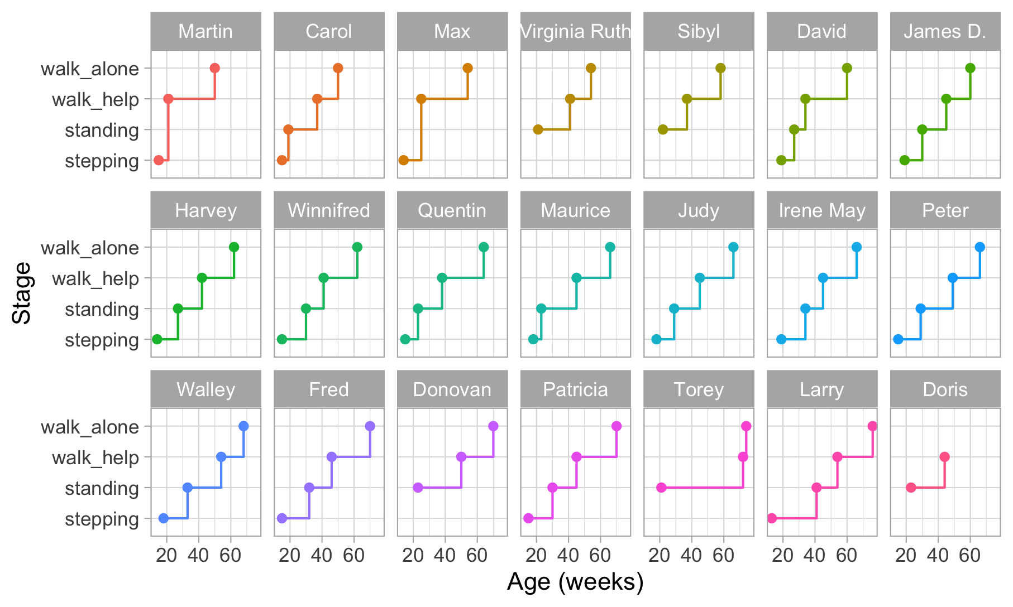

Figure 2.3: Staircase plot indicating the age at which each baby achieves a new milestone of gross-motor functioning.

Figure 2.3 is a visual representation of the information in Table 2.1. Each data point is the age of the first occurrence of the next stage. Before that age, we assume the baby is in the previous stage.

Figure 2.3 makes it easy to spot the quick walkers (Martin, Carol) and slow walkers (Patricia, Torey, Larry). Furthermore, we may also locate children who remain a long time in a particular stage (Torey, Larry) or who jump over stages (Martin, Max).

For ease of plotting, the categories on the vertical axis are equally spaced. The height of the jump from one stage to the next has no sensible interpretation. We might be inclined to think that the vertical distance portrays to how difficult it is to achieve the next stage, but this is inaccurate. Instead, the ability needed to set the next step corresponds to the *horizontal line length* between stages. For example, on average, the line for stepping is rather short in all plots, so going from stepping to standing is relatively easy.

Figure 2.3 presents data from only those visits where a jump occurred. The number of house visits made during the ages of 0-2 years was far higher. Shirley (1931) collected data from 1370 visits, whereas Figure 2.3 plot only the 76 occasions that showed a jump. Thus the data collection needs to be intense and costly to obtain individual curves. Fortunately, there are alternatives that are much more efficient.

## 2.4 Typical questions asked in child development

The emotional, social and physical development of the young child has a direct effect on the adult he or she will become. We may be interested in measuring child development for answering clinical, policy or public health questions.

Table 2.2: Questions whose answers require quantitative measurements of child development.

Level

Question

Individual

What is the child’s gain in development since the last visit?

Individual

What is the difference in development between the child and peers of the same age?

Individual

How does the child’s development compare to a norm?

Group

What is the effect of this intervention on child development?

Group

What is the difference in child development between these two groups?

Population

What is the change in average child development since the last measurement?

Population

What was the effect of implementing this policy on child development?

Population

How does this country compare to other countries in terms of child development?

Table 2.2 lists typical questions whose answers require measuring child development. Note that all questions compare the amount of child development between groups or time points. A few questions compare development for the same child, group or population at different ages. Others compare development at the same age across different children, groups or populations.

# 3 Quantifying child development

This section discusses four principles to quantify child development:

* Age-based measurement (3.1)
* Probability-based measurement (3.2)
* Score-based measurement (3.3)
* Unit-based measurement (3.4)

## 3.1 Age-based measurement of development

### 3.1.1 Motivation for age-based measurement

Milestones form the based building blocks for instruments to measure child development. Methods to quantify growth using separate milestones relate the milestone behaviour to the child’s age. Gesell (1943) (p. 89) formulated this goal as follows:

We think of behaviour in terms of age, and we think of age in terms of behaviour. For any selected age it is possible to sketch a portrait which delineates the behaviour characteristics typical of the age.

There is an extensive literature that quantifies development in terms of the ages at which the child is expected to show a specific behaviour. The oldest methods for quantifying child development calculate an *age equivalent* for achieving a milestone, and compare the child’s age to this age equivalent.

### 3.1.2 Age equivalent and developmental age

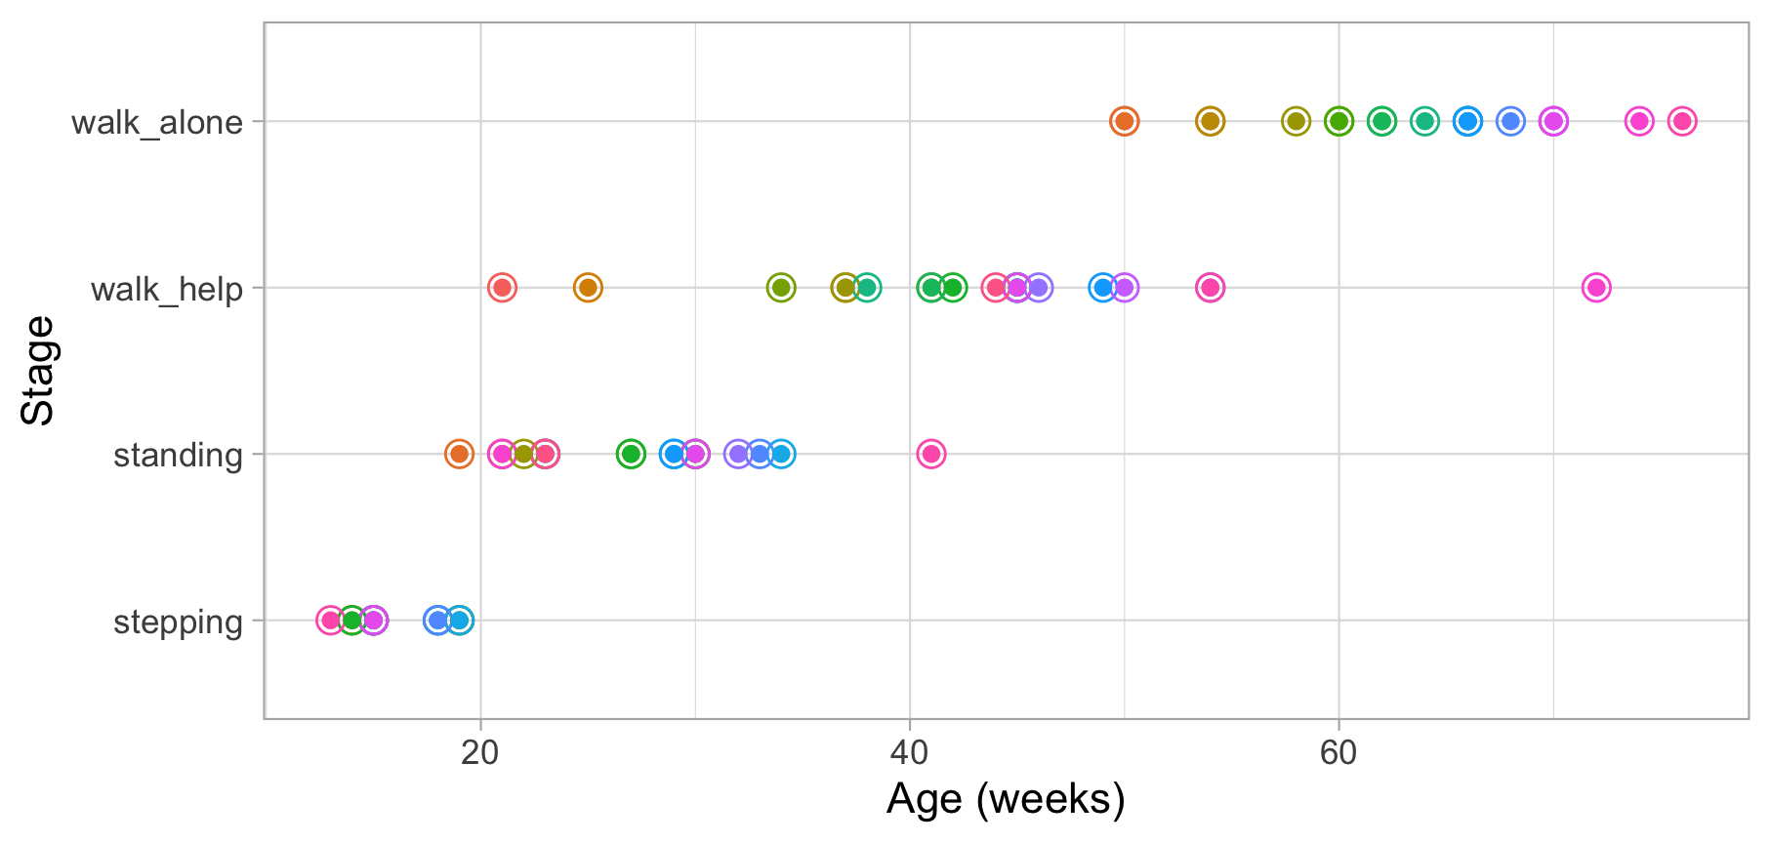

Figure 3.1: Ages at which 21 children achieve four motor development milestones.

Figure 3.1 graphs the ages at which each of the 21 children enter a given stage in Shirley’s motor data of Table 2.1. Since standing follows stepping, children who can stand are older than the children who are stepping. Hence the ages for standing are located more to the right.

Since age and development are so intimately related, we can express the *difficulty* of a milestone as the *mean age* at which children achieve it. For example, Stott (1967) (p. 25) defines the *age equivalent* and its use for measurement, as follows:

The age equivalent of a particular stage is simply the average age at which children reach that particular stage.

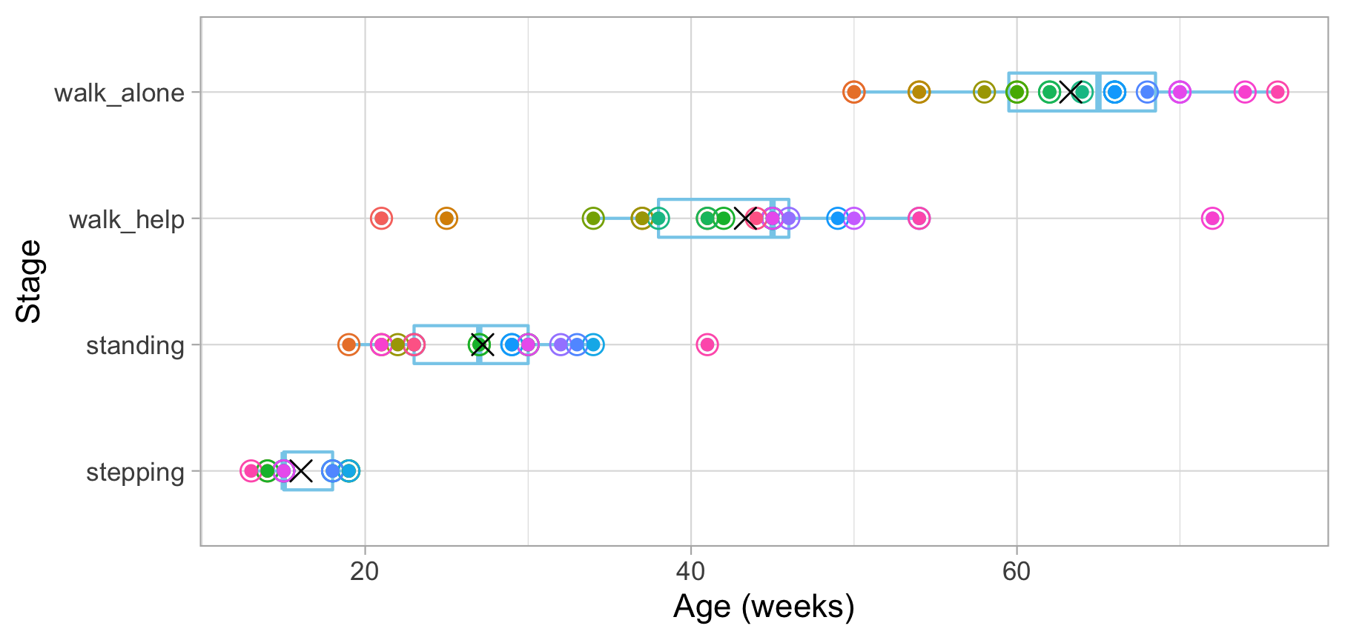

Figure 3.2: Mean (symbol x) and spread of the ages at which 21 children achieve four motor development milestones.

Figure 3.2 adds the mean age and the boxplot at which the children enter the four stages. The difficulty of these milestones can thus be expressed as age equivalents: 16.1 weeks for stepping, 27.2 weeks for standing, 43.3 weeks for walking with help and 63.3 weeks for walking alone.

Thus, a child that is stepping beyond the age of 16.1 weeks is considered later than average, whereas a child already stepping before 27.2 weeks earlier than average. We may also calculate age delta as the difference between the child’s age and the norm age, and express it as “two weeks late” or “three weeks ahead.” Summarizing age delta’s over different milestones has led to concepts like *developmental age* as a measure of a child’s development.

### 3.1.3 Limitations of age-based measurement

Age-based measurement is easy to understand, and widely used in the popular press, but not without pitfalls:

1. Age-based measurement requires us to know the ages at which the child entered a new stage. The mean age can be a biased estimate of item difficulty if visits are widely apart, irregular or missing.
2. Age-based measurement can inform us whether a child is achieving a given milestone early of late. However, it does not tell us what behaviours are characteristic for children of a given age.
3. Age-based measurement cannot exist without an age norm. When there are no norms, we cannot quantify development.
4. Age-based measurement works only at the item level. Although we may average age delta’s over milestones, the choice of milestones is arbitrary.

## 3.2 Probability-based measurement

An alternative is to calculate the *probability* of achieving a milestone at a given age and compare the child’s response to that probability.

The passing probability is an interpretable and relevant measure. An operational advantage of the approach is that the necessary calculations place fewer demands on the available data and can be done even for cross-sectional studies.

### 3.2.1 Example of probability-based measurement

Warning: The `.dots` argument of `group_by()` is deprecated as of dplyr 1.0.0.

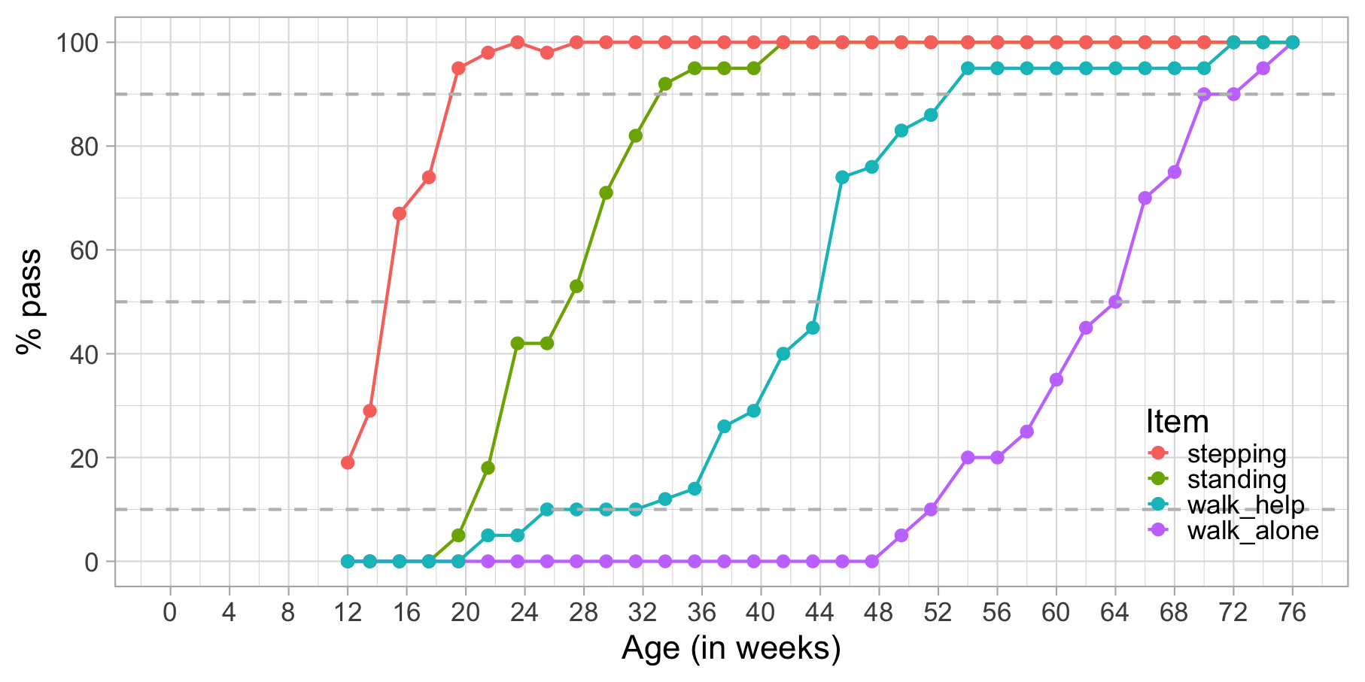

Figure 3.3: Probability of achieving four motor milestones against age.

Figure 3.3 plots the percentage of children achieving each of Shirley’s motor stages against age. There are four cumulative curves, one for each milestone, that indicate the percentage of children that pass.

In analogy to the age equivalent introduced in Section 3.1.2 we can define the *difficulty* of the milestone as the age at which 50 per cent of the children pass. In the Figure we see that the levels of difficulty are approximately 14.2 weeks (stepping), 27.0 weeks (standing), 43.8 weeks (walking with help) and 64.0 weeks (walking alone). Also, we may easily find the ages at which 10 per cent or 90 per cent of the children pass each milestone.

Observe there is a gradual decline in the steepness as we move from stepping to walk_alone. For example, we need an age interval of 13 weeks (33 - 20) to go from 10 to 90 per cent in standing, but need 19 weeks (71 - 52) to go from 10 to 90 per cent in walking alone. Thus, one step on the age axis corresponds to different increments in probability. The flattening pattern is typical for child development and represents evidence that evolution is faster at earlier ages.

### 3.2.2 Limitations of probability-based measurement

Probability-based measurement is a popular way to create instruments for screening on developmental delay. For example, each milestone in the Denver II (Frankenburg et al. 1992) has markers for the 25th, 50th, 75th and 90th age percentile.

1. The same age step corresponds to different probabilities.
2. The measurement cannot exist without some norm population. When norms differ, we cannot compare the measurements.
3. Interpretation is at the milestone level, sometimes supplemented by procedures for counting the number of delays. No aggregate takes all responses into account.

## 3.3 Score-based measurement of development

### 3.3.1 Motivation for score-based measurement

Score-based measurement takes the responses on multiple milestones and counts the total number of items passed as a measure of development. This approach takes all answers into account, hence leading to a more stable result.

One may order milestones in difficulty, and skip those that are too easy, and stop administration for those that are too difficult. In such cases, we cannot merely interpret the sum score of a measure of development. Instead, we need to correct for the subset of administered milestones. The usual working assumption is that the child would have passed all easier milestones and failed on all more difficult ones. We may repeat this procedure for different domains, e.g. motor, cognitive, and so on.

### 3.3.2 Example of score-based measurement

Figure 3.4 is a gross-motor score calculated as the number of milestones passed. It varies from 0 to 3.

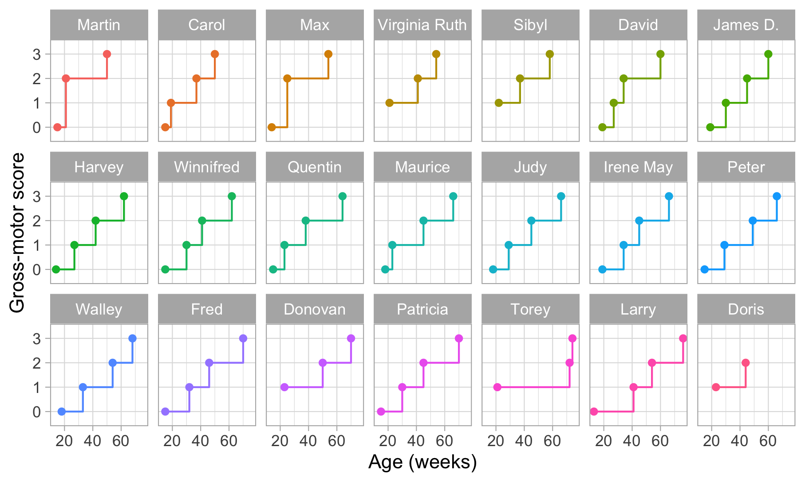

Figure 3.4: Same data as in Figure 2.3, but now with the vertical axis representing gross-motor score.

The plot suggests that the difference in development between scores 0 and 1 is the same as the difference between, say, scores 2 and 3. *This is not correct*. For example, suppose that we express the difficulty of the milestone as an age-equivalent. From section 3.1.2 we see that the difference between stepping and standing is 27.2 - 16.1 = 11.1 weeks, whereas the difference between walking alone and walking with help is 63.3 - 43.3 = 20 weeks. Thus, according to age equivalents scores 0 and 1 should be closer to each other, and ratings 2 and 3 should be drawn more apart.

### 3.3.3 Limitations of score-based measurement

Score-based measurement is today’s dominant approach, but is not without conceptual and logistical issues.

1. The total score depends not only on the actual developmental status of the child, but also on the set of milestones administered. If a milestone is skipped or added, the sum score cannot be interpreted anymore as a measure of developmental status. It might be possible to correct for starting and stopping rules under the assumptions described in Section @(sec:motivscorebased), but such will be involved if intermediate milestones are missing.
2. It is not possible to compare the scores made by different instruments. Some instruments allow conversion to age-conditional scores. However, the sample used to derive such transformations pertain to that tool and does not generalise to others.
3. Domains are hard to separate. For example, some cognitive milestones tap into fine motor capabilities, and vice versa. There are different ways to define domains, so domain interpretation varies by instrument.
4. Administration of a full test may take substantial time. The materials are often proprietary and costly.

## 3.4 Unit-based measurement of development

### 3.4.1 Motivation for unit-based measurement

Unit-based measurement starts by defining ideal properties and derives a procedure to aggregate the responses on milestones into an overall score that will meet this ideal.

Section 2.4 highlighted questions for individuals, groups and populations. There are three questions:

* What is the difference in development over time for the same child, group or community?
* What is the difference in development between different children, groups or populations of the same age?
* How does child development compare to a norm?

In the ideal situation, we would like to have a continuous (latent) variable $D$ (for development) that measures child development. The scale should allow us to quantify *ability* of persons, groups or populations from low to high. It should have a *constant unit* so that a given difference in ability refers to the same quantity across the entire scale. We find the same property in height, where a distance of 10 cm represents the same amount for molecules, people or galaxies. When are these conditions are met, we say that we measure on an *interval scale*.

If we succeed in creating an interval scale for child development, an enormous arsenal of techniques developed for quantitative variables opens up to measure, track and analyze child development. We may then evaluate the status of a child in terms of $D$ points gained, create age-dependent diagrams (just like growth charts for height and weight), devise age-conditional measures for child development, and intelligent adaptive testing schemes. Promising studies on Dutch data van Buuren (2014) suggest that such benefits are well within reach.

### 3.4.2 Example of unit-based measurement

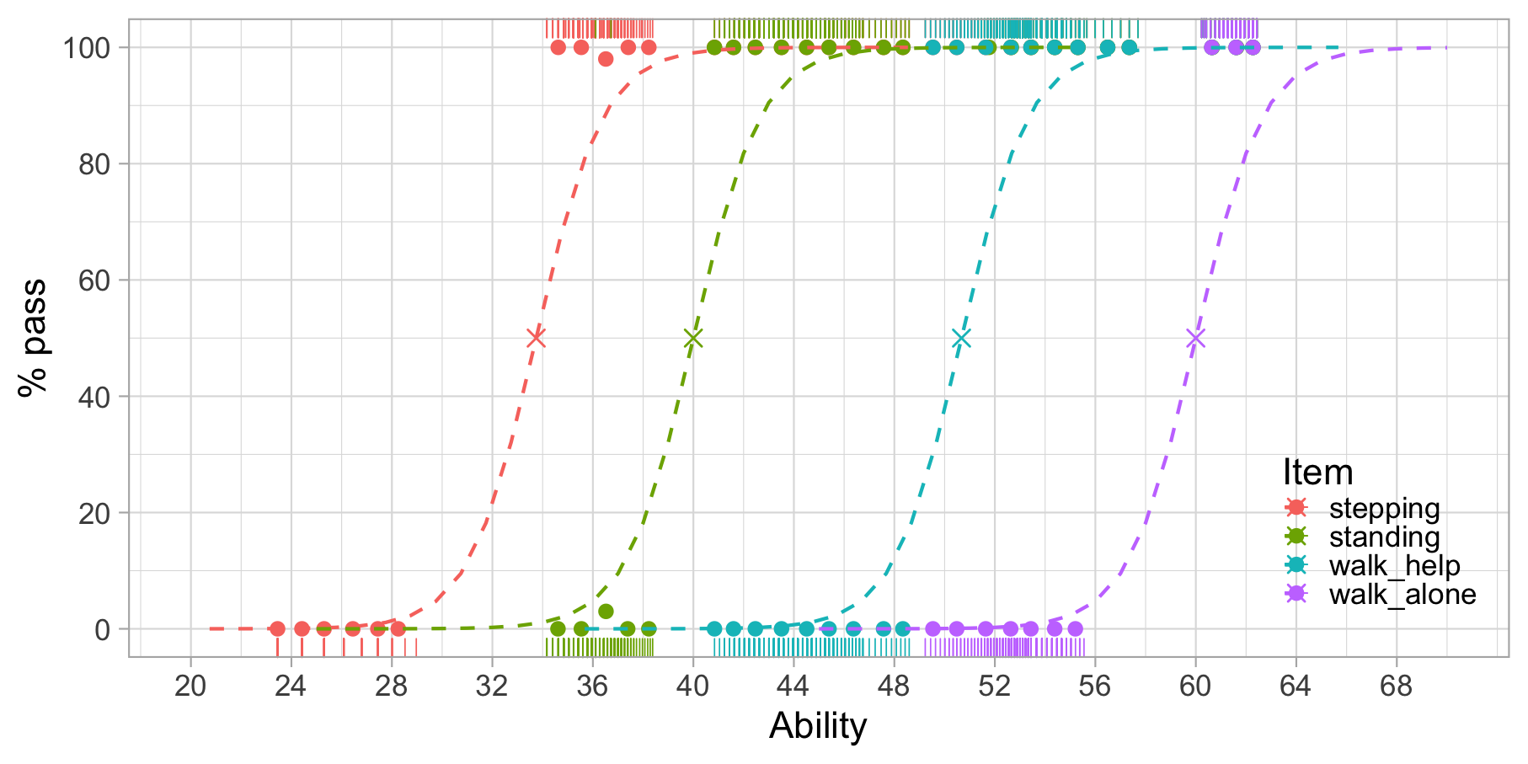

Figure 3.5: Modeled probability of achieving four motor milestones against the D-score.

Figure 3.5 is similar to Figure 3.3, but with Age replaced by Ability. Also, modelled curves have replaced empirical ones, but this is not essential.

We estimated the ability values on the horizontal axis from the data. The values correspond to the amount of development of each visit. Likewise, we calculated the logistic curves from the data. These reflect the probability of passing each milestone *at a given level of ability*.

Figure 3.5 shows that the probability of passing a milestone increases with ability. Items are sorted according to difficulty from left to right. Milestone stepping is the easiest and walk_alone is the most difficult. The point at which a logistic curve crosses the 50 per cent line (marked by a cross) is the *difficulty of the milestone*.

The increase in ability that is needed to go from 10 to 90 per cent is about five units here. Since all curves are parallel, the interval is constant for all scale locations. Thus, the scale is an *interval scale* with a *constant unit of measurement*, the type of measurement needed for answering the basic questions identified in Section 3.4.1.

### 3.4.3 Limitations of unit-based measurement

While unit-based measurement has many advantages, it cannot perform miracles.

1. An important assumption is that the milestones “measure the same thing,” or put differently, are manifestations of a continuous latent variable that can be measured by empirical observations. Unit-based measurement won’t work if there is no sensible latent scale.
2. The portrayed advantages hold only if the discrepancies between the data and the model are relatively small. Since the simplest and most powerful measurement models are strict, it is essential to obtain a good fit between the data and the model.
3. The construction of unit-based measurement requires psychometric expertise, specialized computer software and considerable sample sizes.

## 3.5 A unified framework

This section brings together the four approaches outlined in this section into a unified framework.

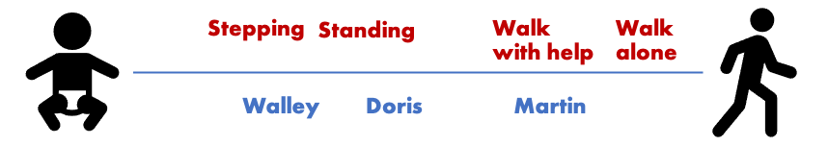

Figure 3.6: Placing milestones and children onto the same line reveals their positions.

Figure 3.6 shows the imaginary positions on a gross-motor continuum of three babies from Figure 2.1 at the age of 30 weeks. Both milestones and children are ordered along the same continuum. Thus, standing is more difficult than stepping, and at week 30, Doris is ahead of Walley in terms of motor development.

More generally, measurement is the process of locating milestones and children on a line. This line represents a *latent variable*, a continuous construct that defines the different poles of the concept that we want to measure. A latent variable ranges from low to high.

The first part of measurement is to determine the location of the milestones on the latent variable. In many cases, the instrument maker has already done that. For example, each length marker on a ruler corresponds to a milestone for measuring length. The manufacturer of the ruler has already placed the marks at the appropriate places on the tool, and we take for granted that each marker has been calibrated correctly.

A milestone for child development is similar to a length marker, but

* we may not know how much development the milestone measures, so its location on the line is unknown, or uncertain;
* we may not know whether the milestone measures child development at all so that it may have no location on the line.

The second part of measurement is to find the location of each child on the line. For child height, this is easy: We place the horizontal headpiece on top of the child’s head and read off the closest height marker. Since we lack a physical ruler for development, we must deduce the child’s location on the line from the responses on a series of well-chosen milestones.

By definition, we cannot observe the values of a latent variable directly. However, we may be able to measure variables (milestones) that are related to the latent variable. For example, we may have scores on tasks like *standing* or *walking with help*.

The *measurement model* specifies the relations between the actual measurements and the latent variable. Under a given measurement model, we may estimate the locations of milestones and children on the line. Section ?? discusses measurement models in more detail.

## 3.6 Why unit-based measurement

(#tab:measurement) Evaluation of four measurement approaches on seven criteria.

|  |  |  |  |  |
| --- | --- | --- | --- | --- |
| Criterion | Age | Probability | Score | Unit |
| Independent of age norm | NO | NO | YES | YES |
| Supports multiple milestones | NO | NO | YES | YES |
| Latent variable | NO | NO | YES | YES |
| Robust to milestone skipping | YES | YES | NO | YES |
| Comparable scores | YES | YES | NO | YES |
| Probability model | NO | YES | NO | YES |
| Defines measurement unit | NO | NO | NO | YES |

This section distinguished four approaches to measure child development: *age-based*, *probability-based*, *score-based* and *unit-based* measurement. Table 3.1 summarizes how the approaches evaluate on nine criteria.

*Age-based measurement* expresses development in age equivalents, whose precise definition depends on the reference population. Age-based measurement does not support multiple milestones and does not use the concept of a latent variable.

*Probability-based measurement* expresses development as age percentiles for a reference population. It is useful for individual milestones but does not support multiple items or a latent variable interpretation.

*Score-based measurement* quantifies development by summing the number of passes. Different instruments make different selections of milestones, so the scores taken are unique to the tool. Thus comparing the measurement obtained by different devices is difficult. Skipping or adding items require corrections.

*Unit-based measurement* defines a unit by a theoretical model. When the data fit the model, we are able to construct instruments that produce values in a standard metric.

# References

Baird, G., E. Simonoff, A. Pickles, S. Chandler, T. Loucas, D. Meldrum, and T. Charman. 2006. “Prevalence of Disorders of the Autism Spectrum in a Population Cohort of Children in South Thames: The Special Needs and Autism Project (SNAP).” *Lancet* 368: 210–15.

Bellman, M., O. Byrne, and R. Sege. 2013. “Developmental Assessment of Children.” *BMJ* 346 (e8687).

Berk, L. E. 2011. *Child Development. 9th Ed.* Boston, MA: Pearson.

Black, Maureen M, Susan P Walker, Lia CH Fernald, Christopher T Andersen, Ann M DiGirolamo, Chunling Lu, Dana C McCoy, Günther Fink, Yusra R Shawar, and Jeremy Shiffman. 2017. “Early Childhood Development Coming of Age: Science Through the Life Course.” *The Lancet* 389 (10064): 77–90.

———. 2017. “Early Childhood Development Coming of Age: Science Through the Life Course.” *The Lancet* 389 (10064): 77–90.

Boggs, D., K. M. Milner, J. Chandna, M. M. Black, V. Cavallera, T. Dua, G. Fink, et al. 2019. “Rating Early Child Development Outcome Measurement Tools for Routine Health Programme Use.” *Archives of Disease in Childhood* 104 (Suppl 1): S22–33.

Britto, P. R., S. J. Lye, K. Proulx, A. K. Yousafzai, S. G. Matthews, T. Vaivada, R. Perez-Escamilla, N. Rao, P. Ip, and L. C. H. Fernald. 2017. “Nurturing Care: Promoting Early Childhood Development.” *The Lancet* 389 (10064): 91–102.

Cameron, N., and B. Bogin. 2012. *Human Growth and Development*. London: Academic Press.

Caspi, A., A. R. Hariri, A. Holmes, R. Uher, and T. E. Moffitt. 2010. “Genetic Sensitivity to the Environment: The Case of the Serotonin Transporter Gene and Its Implications for Studying Complex Diseases and Traits.” *American Journal of Psychiatry* 167 (5): 509–27.

Clark, Helen, Awa Marie Coll-Seck, Anshu Banerjee, Stefan Peterson, Sarah L Dalglish, Shanthi Ameratunga, Dina Balabanova, Maharaj Kishan Bhan, Zulfiqar A Bhutta, and John Borrazzo. 2020. “A Future for the World’s Children? A WHO–UNICEF–Lancet Commission.” *The Lancet* 395 (10224): 605–58.

Ellingsen, K. M. 2016. “Standardized Assessment of Cognitive Development: Instruments and Issues.” In *Early Childhood Assessment in School and Clinical Child Psychology*, edited by E. Garro, 25–49. Springer.

Erikson, E. H. 1963. *Childhood and Society. 2d Ed., Rev. And Enl*. New York, NJ: Norton.

Fernald, L. C. H., E. Prado, P. Kariger, and A. Raikes. 2017. “A Toolkit for Measuring Early Childhood Development in Low and Middle-Income Countries.”

Frankenburg, W. K., J. Dodds, P. Archer, H. Shapiro, and B. Bresnick. 1992. “The Denver II: A Major Revision and Restandardization of the Denver Developmental Screening Test.” *Pediatrics* 89 (1): 91–97.

Gesell, A. 1943. *Infant and Child in the Culture of Today*. Los Angeles, CA: Read Book Ltd.

Horridge, K. A. 2011. “Assessment and Investigation of the Child with Disordered Development.” *Archives of Disease in Childhood-Education and Practice* 96 (1): 9–20.

Jacobusse, G., and S. van Buuren. 2007. “Computerized Adaptive Testing for Measuring Development of Young Children.” *Statistics in Medicine* 26 (13): 2629–38. <https://stefvanbuuren.name/publication/2007-01-01_jacobusse2007/>.

Jacobusse, G., S. van Buuren, and P. H. Verkerk. 2006. “An Interval Scale for Development of Children Aged 0-2 Years.” *Statistics in Medicine* 25 (13): 2272–83. <https://stefvanbuuren.name/publication/2006-01-01_jacobusse2006/>.

Johnson, S. B., A. W. Riley, D. A. Granger, and J. Riis. 2013. “The Science of Early Life Toxic Stress for Pediatric Practice and Advocacy.” *Pediatrics* 131 (2): 319–27.

Kohlberg, L. 1984. *The Psychology of Moral Development: The Nature and Validity of Moral Stages: Vol. 2*. San Francisco: Harpen & Row.

Kolb, B., A. Harker, and R. Gibb. 2017. “Principles of Plasticity in the Developing Brain.” *Developmental Medicine & Child Neurology* 59 (12): 1218–23.

Liebert, R. M., R. W. Poulos, and G. D. Strauss. 1974. *Developmental Psychology*. Englewood Cliffs, NJ: Prentice-Hall, Inc.

Lu, Chunling, Maureen M Black, and Linda M Richter. 2016. “Risk of Poor Development in Young Children in Low-Income and Middle-Income Countries: An Estimation and Analysis at the Global, Regional, and Country Level.” *The Lancet Global Health* 4 (12): e916–22.

Miller, A. C., M. B. Murray, D. R. Thomson, and M. C. Arbour. 2016. “How Consistent Are Associations Between Stunting and Child Development? Evidence from a Meta-Analysis of Associations Between Stunting and Multidimensional Child Development in Fifteen Low-and Middle-Income Countries.” *Public Health Nutrition* 19 (8): 1339–47.

Perkins, J. M., R. Kim, A. Krishna, M. McGovern, V. M. Aguayo, and S. V. Subramanian. 2017. “Understanding the Association Between Stunting and Child Development in Low-and Middle-Income Countries: Next Steps for Research and Intervention.” *Social Science & Medicine* 193: 101–9.

Piaget, J., and B. Inhelder. 1969. *The Psychology of the Child*. New York, NJ: Basic Books.

Rutter, M. 2007. “Genes and Behavior: Nature-Nurture Interplay Explained.” Hogrefe Publishing.

Salkind, N. J., ed. 2002. *Child Development*. Macmillan Library Reference.

Santrock, J. 2011. *Child Development: An Introduction. 13th Ed.* New York, NJ: McGraw-Hill Higher Education.

Shirley, M. M. 1931. *The First Two Years: A Study of Twenty-Five Babies*. Vol. I: Postural and Locomotor Development. Minneapolis: University of Minnesota Press.

———. 1933. *The First Two Years: A Study of Twenty-Five Babies*. Vol. II: Intellectual Development. Minneapolis: University of Minnesota Press.

Shonkhoff, J. P., P. Levitt, N. A. Fox, S. A. Bunge, J. L. Cameron, and G. J. Duncan. 2016. “From Best Practices to Breakthrough Impacts: A Science-Based Approach to Building a More Promising Future for Young Children and Families.” Harvard University, Center on the Developing Child Cambridge, MA.

Stott, L. H. 1967. *Child Development: An Individual Longitudinal Approach*. New York, NJ: Holt, Rinehart; Winston, Inc.

Sudfeld, C. R., D. C. McCoy, G. Danaei, G. Fink, M. Ezzati, K. G. Andrews, and W. W. Fawzi. 2015. “Linear Growth and Child Development in Low-and Middle-Income Countries: A Meta-Analysis.” *Pediatrics* 135 (5): e1266–75.

UNICEF. 2019. “The State of the World’s Children 2019: Children, Food and Nutrition: Growing Well in a Changing World.” *UNICEF*.

van Buuren, S. 2014. “Growth Charts of Human Development.” *Statistical Methods in Medical Research* 23 (4): 346–68. <https://stefvanbuuren.name/publication/2014-01-01_vanbuuren2014gc/>.

Weber, Ann M, Marta Rubio-Codina, Susan P Walker, Stef van Buuren, Iris Eekhout, Sally M Grantham-McGregor, Maria Caridad Araujo, et al. 2019. “The D-score: A Metric for Interpreting the Early Development of Infants and Toddlers Across Global Settings.” *BMJ Global Health* 4 (6). <https://doi.org/10.1136/bmjgh-2019-001724>.

Wit, J. M., J. H. Himes, S. van Buuren, D. M. Denno, and P. S. Suchdev. 2017. “Practical Application of Linear Growth Measurements in Clinical Research in Low-and Middle-Income Countries.” *Hormone Research in Paediatrics* 88 (1): 79–90.